Synopsis

Predictive Analytics for Urban Water Demand

Problem Id: 06

Student Name: Nakshatra Agarwal
University Roll number:2028775
Section: P

Student Name: Manvi Arora
University Roll number:2028761
Section: P

Student Name: Ruhee Gupta
University Roll number:2028829
Section: P

- Problem Description:
Efficient urban water management is a critical challenge due to increasing population and varying consumption patterns. Accurate prediction of daily water usage helps authorities optimize supply, reduce wastage, and prevent shortages. This project focuses on developing a predictive analytics model to estimate daily water consumption based on factors such as household size, seasonal variations, and garden area.
A dataset will be curated representing these influencing factors and corresponding water usage. Machine learning techniques, specifically Linear Regression, will be applied to model the relationship between input variables and water demand. Data preprocessing techniques such as handling missing values and feature scaling using StandardScaler will be implemented to improve model performance.
The model will be evaluated using residual analysis to assess prediction accuracy. This project demonstrates how data-driven approaches can support smart city planning and sustainable resource management.
- Steps of Implementation:
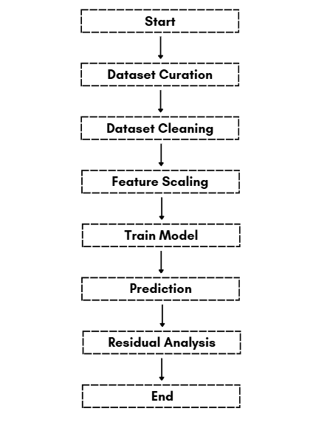

- Expected Modules/ Libraries to be used :
- NumPy
Used for numerical computations and array operations.
- Pandas
Used for dataset handling, cleaning, and manipulation.
- Scikit-learn
Provides tools for StandardScaler and Linear Regression.
- Matplotlib / Seaborn
Used for visualization of data and residual plots.
- Expected Evaluation metrics and Plots to be used:
Metrics:
- Mean Absolute Error (MAE) → Measures average prediction error
- Mean Squared Error (MSE) → Penalizes larger errors
- R² Score → Measures model accuracy
Plots:
- Residual Plot → Check error distribution
- Actual vs Predicted Plot → Visualize model performance
- Required topics from the subject:

1. Data Preprocessing: Involves cleaning and preparing raw data before feeding it into the model
2. Feature Scaling (StandardScaler): StandardScaler is used to normalize features so that they have zero mean and unit variance.
4. Linear Regression:A statistical method used to model the relationship between dependent and independent variables.
5. Scikit-learn (sklearn) Library: A Python library used for implementing machine learning algorithms.
6. Data Visualization: Using libraries like Matplotlib or Seaborn to plot graphs such as residual plots and prediction comparisons for better understanding.

- Platform Required:
Visual studio/ MS excel
- Books and Link Sources:
- Hands-On Machine Learning – Aurélien Géron
- Python for Data Analysis – Wes McKinney
- Scikit-learn Documentation
- Kaggle (Dataset and ML references)

- Prompt used for Dataset:
“now generate me a dataset of 2 lakh values with missing/null values , remove any outliers and keep random decimal range “

